
Company
Logotype

Cone Beam Computed Tomography- Report



Porur Dental X-rays & CBCT

Patient Name : Mr. Sundar Rajan | Date of Report : 20.05.2024
Age/ Gender : 66 years/ Male | Region of Interest : CBCT Maxilla
Referring doctor: Dr. Jayakrishna | Indication : Implant assessment
Clinical Notes: Nil
PATIENT INFORMATION

CBCT- Maxilla provided
CBCT – IMAGE DETAILS

RADIOGRAPHIC INTERPRETATION

- Completely missing crown and root in relation to 11, 12, 13, 16, 18, 21, 22, 23, 24, 25, 26, 27, 28.
- The maxillary alveolar ridge is present with normal trabecular pattern.

IMPLANT ASSESSMENT

 | 11 region | 12 region | 13 region | 14 region | 21 region | 22 region | 23 region | 24 region
Sub-Crestal | 6.13 | 6.05 | 7.24 | 7.07 | 6.39 | 6.32 | 7.62 | 7.9
Mid- Crestal | 6.87 | 6.32 | 7.02 | 8.58 | 7.62 | 7.35 | 7.84 | 8.8
Distance between the alveolar ridge and Floor of the Nasal cavity (in mm) | 19.58 | 18.01 | 18.81 | 8.06 | 18.44 | 16.21 | 12.42 | 9.26

 | 15 region | 16 region | 17 region | 25 region | 26 region | 27 region
Sub-Crestal (in mm) | 8.83 | 8.55 | 7.24 | 9.94 | 8.77 | -
Mid- Crestal (in mm) | 9.84 | 10.18 | 8.13 | 9.48 | 10.05 | -
Distance between the alveolar ridge and floor of the maxillary sinus (in mm) | 10.73 | 6.14 | 4.3 | 7.94 | 5.68 | 2.31

RADIOGRAPHIC IMPRESSION

- Partially edentulous maxillary arch.
- Generalized Chronic Periodontitis.

Kindly correlate with clinical findings


IMAGES FOR REFERENCE

RECONSTRUCTED PANORAMIC VIEW
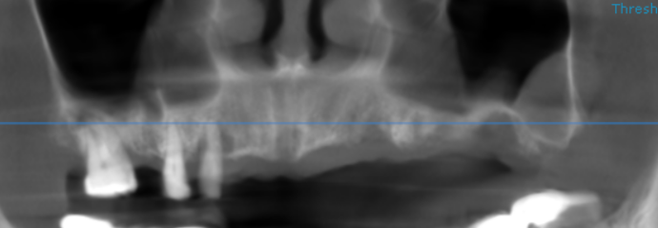

3-DIMENSIONAL VIEW

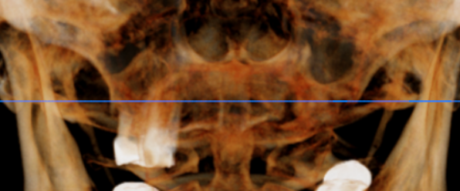

CROSS SECTIONAL VIEW

11 region | 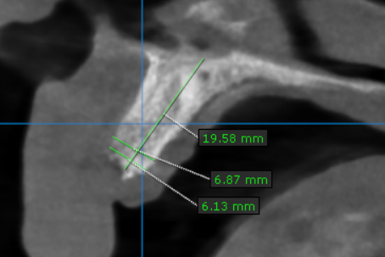
12 region | 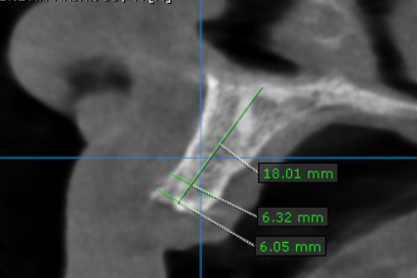
13 region | 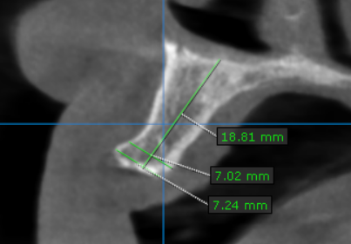
14 region | 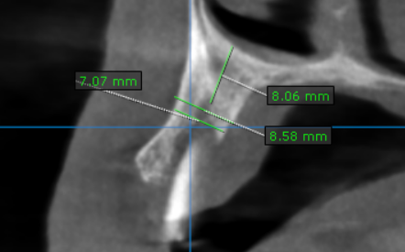
15 region | 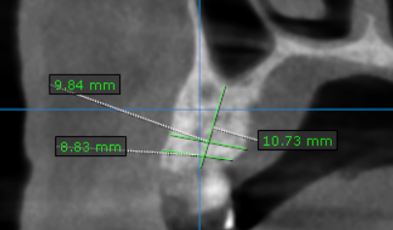
16 region | 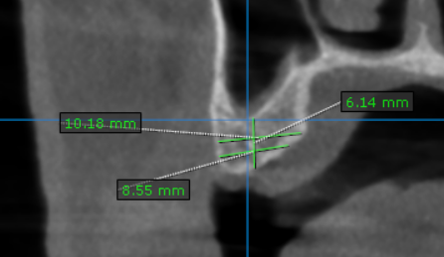
17 region | 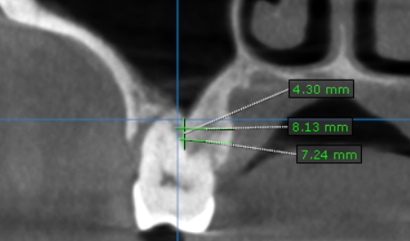
21 region | 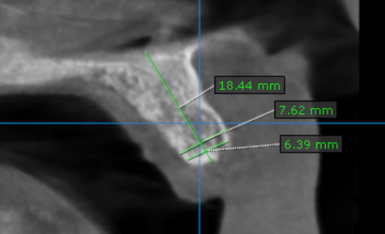
22 region | 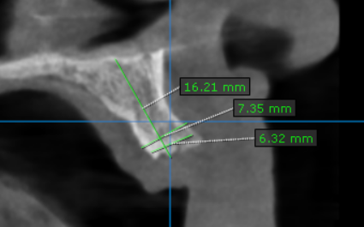
23 region | 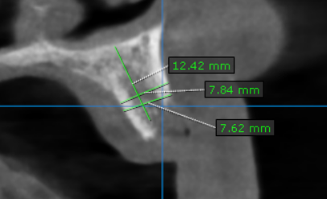
24 region | 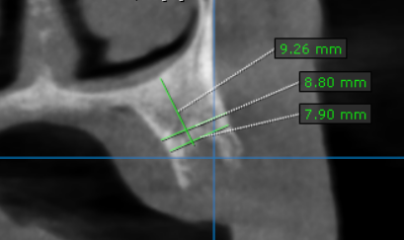
25 region | 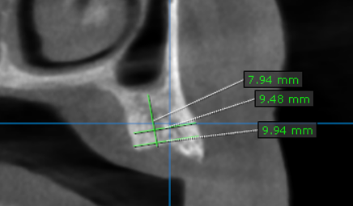
26 region | 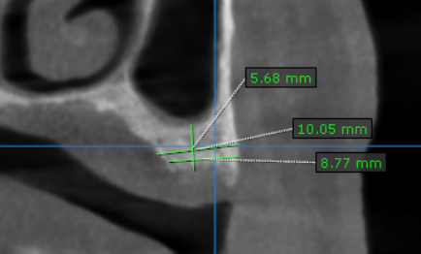
27 region | 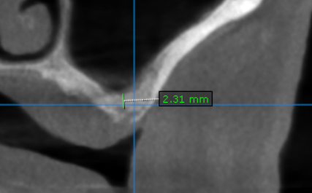

**** End of report ****

